DOMAIN UNDERSTANDING



**Class:**

AI44

**Mentor:**

Martijn Lamers

**Members:**

Eva Bijker Bas van Mil

Antonia Dineva Ryan van Wegen

David Lima Ruas van Rijthoven Alex Svetoslavov

# Introduction

Ordina is a local, independent IT service company, in Benelux with approximately 2.650 employees.

Before the Corona crisis started, most consultants worked on projects and assignments at the customers, spread out over the Netherlands. Chapter 3 will go into more detail about Ordina and its values.

Obviously, Ordina stimulates their employees to travel sustainably, e.g., by train or electric car. Traveling by train comes often with delays or redirections. Ordina values their customers and therefore the consultant should be at the customers in time.

# Table of Contents

1 Introduction 2

Table of Contents 3

2 Ordina 4

2.1 What is Ordina? 4

2.2 Core values 4

2.2.1 We discover: 4

2.2.2 We connect: 4

2.2.3 We accelerate: 4

2.3 Where is Ordina located? 5

3 Main and Sub-questions 6

4 General train travel information: 7

4.1 Why is traveling by train sustainable? Is travel by train sustainable in the Netherlands? 7

4.2 What train companies do we have in the Netherlands and what kind of train subscriptions do they have? 8

4.3 How reliable is train travel? 9

4.3.1 Where is the most delay? 9

4.3.2 How often is there a delay with the trains and what is the average delay?**?** 9

5 Impact 10

5.1 On average how many people use which type of transport to go to work? (IT consultants) 10

6 Stakeholders 11

6.1 Who is involved on this project? /Who are the stakeholders? 11

8 References 13

# Ordina

## What is Ordina?

Ordina is an independent IT service provider in Benelux. They are the partner who helps people with digital transformation and, true to their vision, ensures that they stay Ahead of Change. Ordina does this by connecting technology, business challenges and people. They help with digital transformation, develop smart IT applications, launch new digital services, and make sure that people embrace them. As a result, Ordina creates a digital lead so an organization can stay ahead.

## Core values

These core values drive Ordina. They summarize what they stand for and how they do things at Ordina. This Ordina DNA is ingrained in every Ordina professional and ensures that they know their clients inside out and use their expertise, professional expertise, and talent to deliver the best possible service:

### We discover:

From professionalism to being ahead in your field. We are curious and we are open to new developments.  
This helps us to identify opportunities and threats and find out what they mean. Every single day, we discover how to use our talent optimally, and how we can continue to develop our professional skills.  
So, we can be ahead in our field and proactively help our clients stay ‘Ahead of change.’

### We connect:

From working together to accepting responsibility for the result. We are open-minded, inclusive, and enterprising.  
This helps us make connections and build relationships. Based on collaboration in High performance teams, Ordina accepts responsibility for the result.  
Proactively connecting inside with outside and vice versa. To realize the optimum result. Win-win situations with the best possible result for every stakeholder.

### We accelerate:

From knowing our clients to providing them with a digital edge. We focus on clients and strive for quality.  
This helps us look ahead and helps our clients to accelerate. To proactively develop the best solutions for clients based on our business propositions.  
Ambitious solutions that make a real difference, that truly help clients to gain a digital edge.

## Where is Ordina located?

Ordina has a couple of offices around Benelux:

Netherlands:

* Nieuwegein
* Groningen
* Eindhoven
* Amsterdam

Belgium:

* Mechelen
* Gent
* Lummen
* Namen

Luxembourg:

* Windhof

The head office in the Netherlands of Ordina, is located in Nieuwegein. It is located directly next to the highway, and it is easily accessible by car and public transport.[1]

# Main and Sub-questions

To understand the domain surrounding this project we came up with the following main- and sub-questions:

***How can we optimize the travel time by train for Ordina employees?\****

* Why is traveling by train sustainable? Is travel by train sustainable in the Netherlands?
* What train companies do we have in the Netherlands and what kind of train subscriptions do they have?
  + How reliable is train travel?
  + Where is the most delay?
* How often is there a delay with the trains and what is the average delay?**?**
* On average how many people use which type of transport to go to work? (IT consultants)
* Who are involved on this project?/Who are the stakeholders?

This will help us to understand the domain of the case and eventually help us to answer the main question.

* Optimize : get from a to b faster by avoiding the train rides with the biggest chance of delay

# General train travel information:

## Why is traveling by train sustainable? Is travel by train sustainable in the Netherlands?

According to the NS (Nederlandse Spoorwegen) website, taking care of the environment is essential and society should contribute to it. There are several types of trains on the rail network in the Netherlands. The majority are under the operation of NS railway company. NS focuses on sustainable mobility and aims to use green energy without CO2 emissions. Their goal is to operate on 100% sustainable energy without the back up of fossil fuels.

They also have implemented circular enterprise which mean “There is no such thing as waste.” That includes limitation of new resources use and optimization of material. NS is engaged in green enterprise to contribute to biodiversity, health, and climate change in a positive way. [2]

## What train companies do we have in the Netherlands and what kind of train subscriptions do they have?

In the Netherlands there are multiple railway companies. The largest company is the NS, short for Nederlandse Spoorwegen, which translates to the Dutch railways. Besides the NS, there are a few smaller railway companies, such as Keolis Nederland, Breng and Arriva. These companies operate partially in the Netherlands, but they only work on limited city connections. For example, Arriva operates mostly in the east side of the Netherlands with their trains. [3]

The NS has many different types of subscriptions, some are quite cheap and only provide conditional discounts while others make travel free entirely.

These are the most relevant for Ordina:

|  |  |  |
| --- | --- | --- |
| Name | Advantages | Price (EUR per month) |
| Dal Voordeel | 40% discount during off-peak hours | 5.10 (now discount 2,50 (29-3-2022)) |
| Altijd Voordeel | Travel with discounts in both the peak and off-peak hours | 24.20 |
| Dal vrij | Unlimited free traveling during off-peak hours | 107.90 |
| Traject Vrij | Unlimited free train travel but only on a specific route | fixed annual price dependent on route |
| Altijd Vrij | Unlimited train travel | 326.60 |

Arriva also has a few different types of subscriptions. One of them is called ‘Goede zaak pas,’ which is meant for companies to arrange efficient employee transport.

## How reliable is train travel?

### Where is the most delay?

Following research by RTL Nieuws and Vertraagd.com, the most disruptions in 2019 were in Brabant. Because of the corona virus in 2020, this research will be most accurate. Most stations in Brabant score lower on punctuality than the average in the Netherlands.

Station Sneek is on top of the list with an 'on-time' percentage of 98,9 percent. The top 6 concludes stations on the same route. All the way on the bottom of the list, there is station Eygelshoven Markt near Heerlen, with a percentage of 85,1 percent.

Sneek has a remarkably high punctuality because the route does not cross any other route which can lead to any disruption. Besides that, the route is also quite short compared to the rest. Stations where international trains run get lower punctuality. The route between Maastricht and Aken has been there since January 2019. The train that uses this route has a new technique which makes it possible to use the Dutch electricity voltage and the German one. This coherence and complexity can negatively affect punctuality.

In Brabant, the punctuality is worse than the rest of the Netherlands, that is because in Brabant there are a lot of intersections on the same level, which result in trains waiting for each other. There is also a route for freight trains which makes it harder for NS. In January and February there was a failed software-update for the high-speed rail. This caused a lot of trouble; this was fixed in spring but will still affect average punctuality. [4]

### How often is there a delay with the trains and what is the average delay?**?**

“Between January 1, 2011, and February 22, 2022, Rijden de Treinen has reported 39,962 disruptions. This is an average of 10 disruptions per day.

The total duration for all disruptions in this period was 11 years, 24 days, 17 hours, 59 minutes. This translates to an average of 23 hours, 50 minutes with train disruptions per day.

The average duration for a disruption in this period was 2 hours, 26 minutes.”[5]

# Impact

## On average how many people use which type of transport to go to work? (IT consultants)

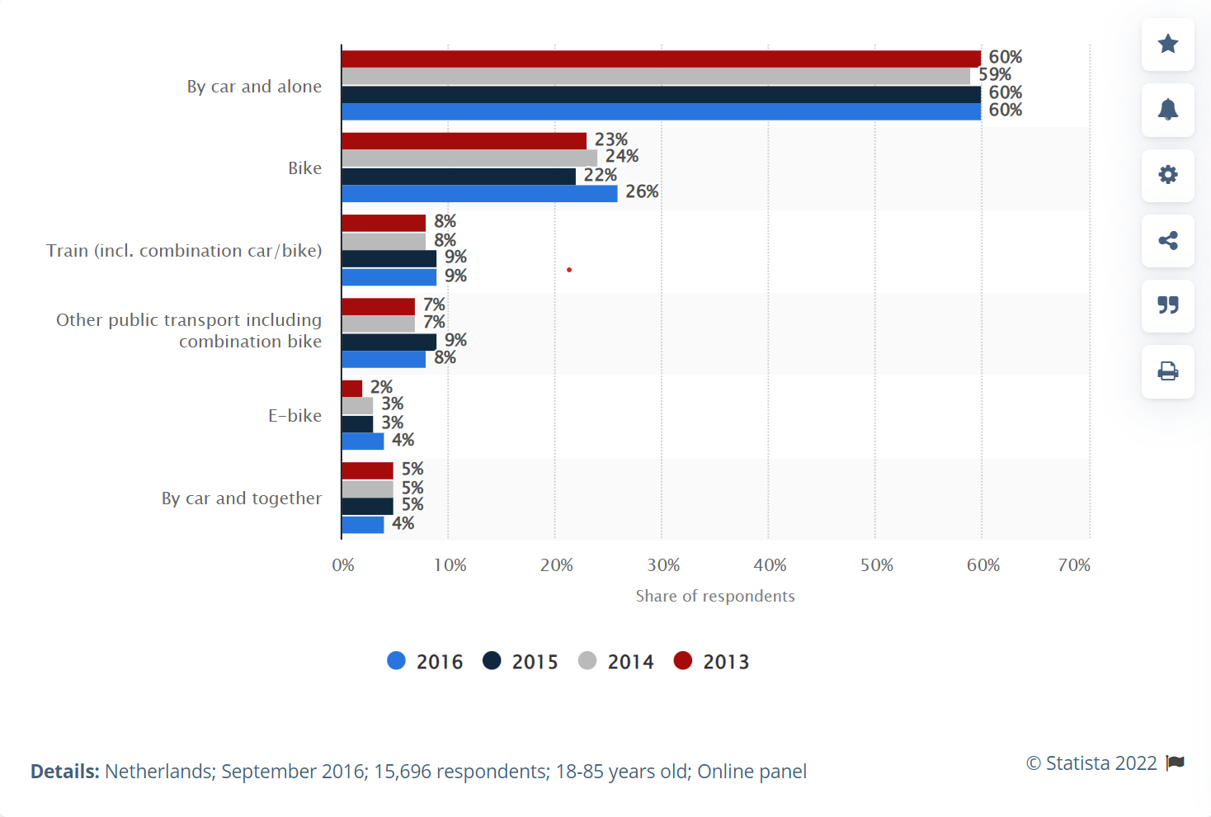

This graph is taken from Statista research published in 2016 from residents of the Netherlands. The people that responded are aged between 18-85 and the number of respondents is 15, 696. It shows the percentage of people travelling to work by different means of transport. On the x-axes we have the share of respondents in percentage and on the y-axis, we have the type of transport. The 4 colors indicate the year that the research was made. So, this bar graph has data from 4 years.

Most correspondents used cars and travelled alone. The lowest percentage of people used E-bike.

According to this statistic in 2016, 9% of the respondents used train to travel to work.

In comparison most respondents used car, with score up to 60%.

The car was the most used means of transport to work in 2016. [6]

# Stakeholders

## Who is involved on this project? /Who are the stakeholders?

The project will go through several phases. They will be marked by meeting with the client after which feedback will be collected and considered. The stakeholders are everyone that is involved in the project either as a developer, customer, or user. Those roles and their representatives are outlined below.

* Our client is Ordina company. Our project tutor is Mr. Lamers. They are the people who will be reported to and keep informed about the project development. They are also the people whose feedback will be collected before the final product is presented and ready to be used by the end user.
* The end user is Ordina company employees. They are the target audience and the one who will use the product.
* Pythonatic is the group working on this project to deliver the product to meet the stakeholders' needs in the end. Based on the planning outlined in this document they will work to deliver the agreed upon product.
* NS/the train companies are also an indirect stakeholder of our project. This is because if we can accurately predict which trains are going to have a delay then they would also want to look into it so they can improve their services.

# References

*ns.nl*. (n.d.). Retrieved from ns.nl: https://www.ns.nl/en/about-ns/sustainability

Ordina. (n.d.). *Over Ordina*. Retrieved from Ordina : https://www.ordina.nl/en/about-ordina/

Rijden de treinen. (n.d.). *Statistics*. Retrieved from Rijden de treinen: https://www.rijdendetreinen.nl/en/statistics

RTL Nieuws. (2019, December 7). *Brabanders moeten vaker wachten op de trein dan de rest van Nederland*. Retrieved from rtlnieuws: https://www.rtlnieuws.nl/nieuws/nederland/artikel/4944606/trein-station-ns-arriva-vertraging-brabant-vertraagdcom

Statista. (2016, September). *Share of respondents who commute to work in the Netherlands from 2013 to 2016, by mode of transport*. Retrieved from Statista: https://www.statista.com/statistics/673009/commute-to-work-in-the-netherlands-by-mode-of-transport/

Various train hobbyists. (sd). *Materieel*. Opgehaald van Treinposities: https://treinposities.nl/materieel

1. (Ordina, n.d.)
2. (ns.nl, n.d.)
3. (Various train hobbyists, sd)
4. (RTL Nieuws, 2019)
5. (Rijden de treinen, n.d.)
6. (Statista, 2016)